Name: Class:

Task 1
(a) Look at the following table of numbers. Tick each of the numbers that are valid IP addresses.
IP address | Tick if valid IP address
109.194.175.75
723.220.119.49
95.0.256.42
224.115.0.218
78.812.28.132
(b) Convert each of the valid IP addresses in the table above into their 32-bit binary representation.

(c) An old PC currently doesn’t have any way of connecting to a home router so that it can connect to the Internet. The user wants to connect to the router using a network cable.
(i) Explain what hardware would need to be fitted to the PC to connect it to the router.

(ii) The user also would like to connect the computer wirelessly to an old local network they created. Is this possible? If so, what hardware would they need?

Task 2
Look at the following diagram of a home network:
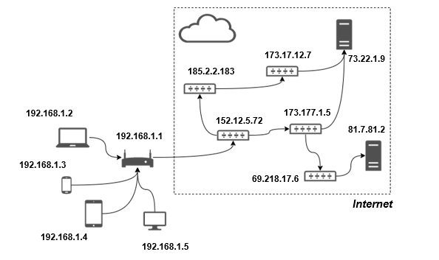
(a) What is the IP address of the home router?

(b) What is the IP address of the laptop?

(c) State the IP address of one server on the Internet.

(d) The laptop wants to send data packets to the server with the IP address 73.22.1.9. Give the possible routes that the packets could take.

